Chapter 5.6 Obtaining Pure Substances
Matter
Pure Substances
Mixtures
Elements
Compounds
Homogeneous Mixtures
Heterogeneous Mixtures

Filtration

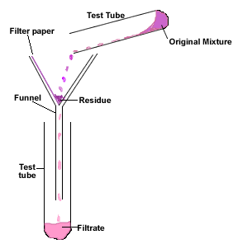
Filtration can only be used to separate an _____________________ substance from a mixture. This is most often a _______________ in a _________________ (e.g. sand in water removed by filtering) but can be ________________ in __________ (e.g. dirt in air removed during vacuuming).
With standard filtration equipment (filter funnel and filter paper), the substance caught in the paper is called the __________________ and the substance that flows through the paper is called the ____________________.

Crystallisation (Evaporation)
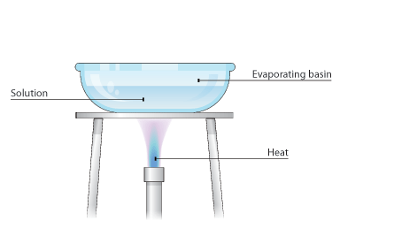
This is used to separate a _________________ component from a solution. The simplest way to do this is to heat the solution until all the __________________ is driven off. This will leave crystals of _______________ behind.

Crystallisation (Recrystallisation)

Recrystallisation is used to separate _______ solutes that are both soluble in the hot solvent, however one is less soluble as the solvent _____________ and will therefore crystallise out and be able to be filtered off. This can also be used to __________________ an impure substance by using heat to dissolve what you want and then filtering off any impurities.
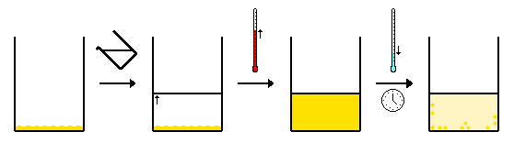

Solvent Extraction

Solvent extraction is used to separate substances that dissolve in different _____________________ solvents. This is usually based on the ‘like dissolves like’ rule that polar solutes dissolve in polar solvents and non-polar solutes dissolve in non-polar solvents.
e.g. water (polar) e.g. hexane (non-polar)

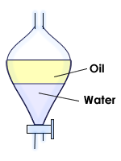
If you had 2 substances such as iodine and sodium chloride, the sodium chloride would dissolve in the _______________ and the iodine would dissolve in the __________________. The water and the hexane form ___________________ since they are immiscible and then a separating funnel can be used to tap off each layer. Evaporation of the solvent then leaves the original solute.

Distillation

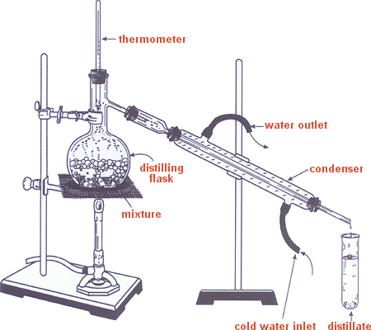
Distillation is used when the 2 substances have distinctly different ____________________ _________________. It can be useful to separate solids and liquids using distillation because at the end you are able to keep both the _____________ and the _________________, unlike with evaporation where you are only left with the solute. Most often however, distillation is used to separate 2 ___________________ with different boiling points such as _______________ and ___________________. The alcohol will boil first, vaporise, move into the condenser where the water jacket brings the temperature down enough to reform liquid alcohol and then it trickles out as the distillate. Meanwhile the water has remained in the distillation flask.

Chromatography

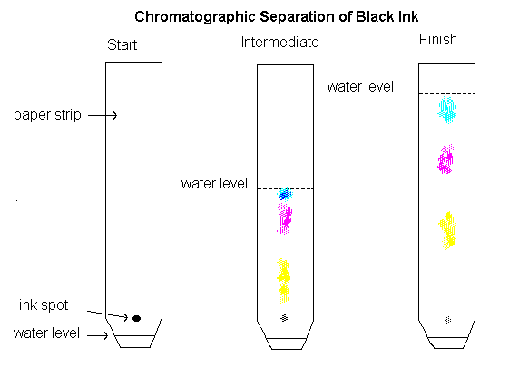
Chromatography is used to separate ______________ quantities of mixtures. There are different chromatography techniques such as ________________, _________ and ________________ chromatography. Each technique consists of a ______________________ phase (non-moving) such as paper, silica, alumina and a __________________ phase (moving). The separation occurs as the mobile phase moves through the stationary phase carrying the mixture. Different ______________________ of the mixture will _________________ to the stationary phase with different _____________________. A component that adheres strongly will move slowly whereas a component that adheres weakly will move faster along the stationary phase. This technique is commonly used to separate dyes, pigments, drugs, cigarette smoke etc.
QUESTIONS

- Match each separation technique to its appropriate description.

Distillation Used for small amounts of substances, based on the different strength of adherence of the components to an inert surface.

Filtration A quick method to retrieve a soluble solid from a solution.

Evaporation Used when 2 substances can be separated based on their differing polarities, by adding a solvent in which only one can dissolve.

Recrystallisation Used when components in a mixture have different boiling points.

Chromatography Used when 2 substances are both soluble in the same solvent, but one is less soluble at cooler temperatures.

Solvent extraction Used to remove an insoluble solid from a liquid (or gas).

- Which separation technique would you use to remove the named component from each of the mixtures?

Mixture | Component to be retrieved | Separation technique
Salt water | Water
Muddy water | Mud
Air | Carbon monoxide
Purple food colouring | Red dye
Air | Dirt
Wine | Alcohol
Powdered salt (NaCl) and ground candle wax | Candle wax
Aspirin | Salicylic acid
Copper II sulfate solution | Copper II sulfate powder

